**Terms and Conditions for Property Owners**

**Last updated December 27, 2024**

Welcome to Akosombo River View Land and Island Property Owners Association LBG ("**ARVIPOA**," "**we**," "**us**," "**our**"), doing business as ARVIPOA. These Terms and Conditions ("Terms") govern your use of our platform and services as a property owner ("you," "your"). By accessing or using our services, you agree to these Terms. If you do not agree, you must discontinue using our services immediately.

### 1. Eligibility and Account Registration

1.1 **Eligibility**You must be at least 18 years old and legally authorized to list properties for sale or rent. By registering with ARVIPOA, you confirm that all property information provided is accurate and that you hold all necessary rights to list the property. This ensures compliance with both local and international property laws, where applicable.

1.2 **Account Registration**

* Property owners must create an account through our web interface to gain access to listing and management tools.
* Accurate information, including your **name**, **email address**, **phone number**, and **property details**, must be provided during registration.
* You are responsible for maintaining the confidentiality of your username and password to prevent unauthorized access even though our system is highly secured, we still advise account owners to take precaution.
* Notify us immediately at [**support@arvipoa.org**](mailto:support@arvipoa.org) if you suspect unauthorized access to your account to safeguard your information and ensure uninterrupted service.

### 2. Property Listing Requirements

2.1 **Mandatory Documentation**Property owners are required to upload the following documents during property listing to ensure the accuracy and legality of listings:

* **Site Plan**: A detailed layout of the property’s location and boundaries.
* **Building Plan**: Architectural blueprints and structural plans for the property.
* **Indentures**: Legal agreements related to property ownership or transfer.
* **Permits**: Relevant government-issued property permits.
* **Property Rate Receipt**: Proof of property rate payments.
* **Electricity Meter Number**: Verification of utility registration.
* **Water Meter Number**: Proof of water utility registration.

2.2 **Accuracy of Information**

* All property descriptions, photographs, and videos must accurately represent the property’s current condition and features.
* Owners must disclose any material defects or issues that could impact buyers or tenants.
* ARVIPOA reserves the right to suspend or remove listings that are found to be misleading, inaccurate, fraudulent, or otherwise non-compliant with these Terms.

2.3 **Property Verification**ARVIPOA conducts verification processes to ensure property authenticity. These include:

* **Drone-Assisted Inspections**: Modern DJI Enterprise drones equipped with Real-Time Kinematic (RTK) and GPS systems survey property boundaries, providing aerial and 360-degree photographs.



* **Augmented Reality Glasses**: Inspectors use MR VIEW AR glasses to capture detailed interior and exterior footage.

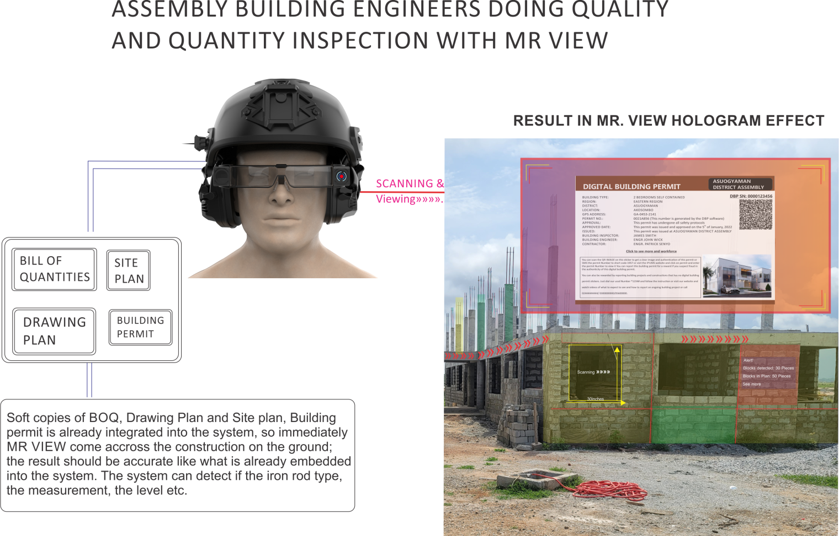

* **Digital Address System**: Every property is assigned a **Main Unique Digital Address (MUDA)** and **Sub Unique Digital Address (SUDA)** for detailed location identification. Any new SUDA generated within a registered property’s boundaries will be invalid to prevent fraudulent practices.

2.4 **Digital and Local Address Management**

* The **Digital Address System**, powered by Ghana Post GPS, ensures every part of a property is accurately located and registered.
* ARVIPOA mitigates fraudulent address practices by verifying each property’s digital address and integrating it with our system.

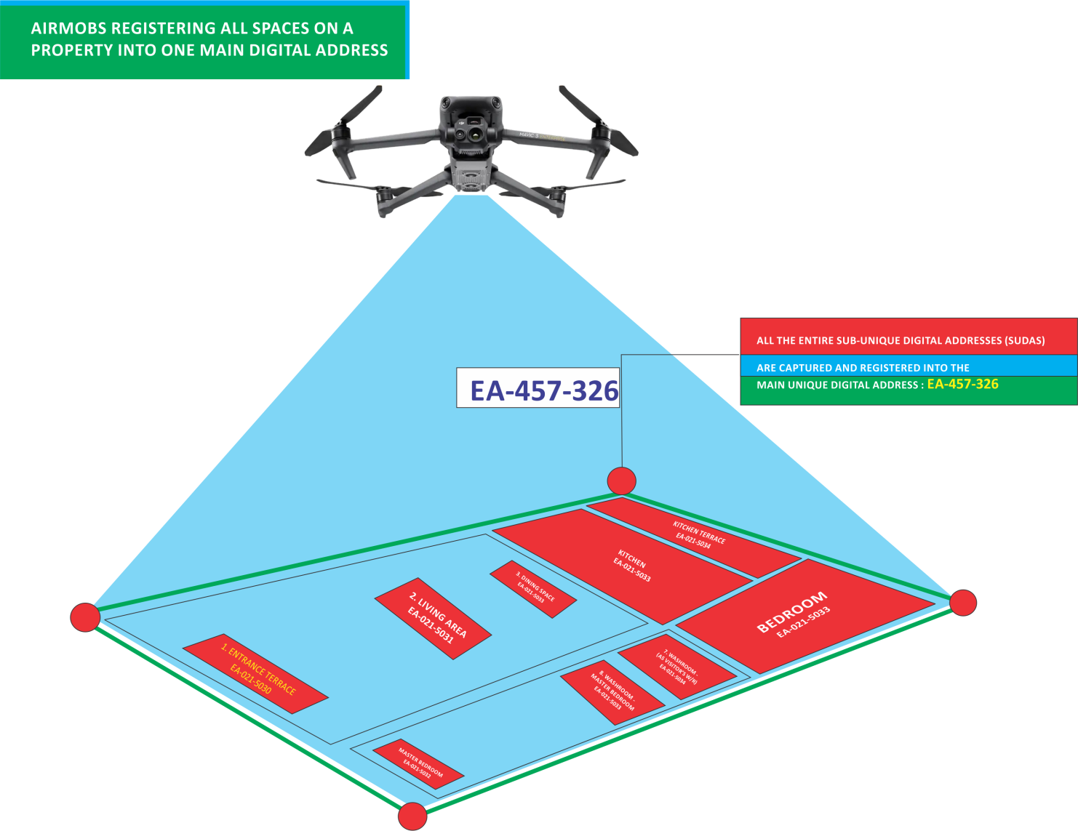

### 3. Additional Services Provided by ARVIPOA

3.1 **Property Management Services**

* ARVIPOA offers drone-based site inspections, property surveys, and land title registration facilitation.

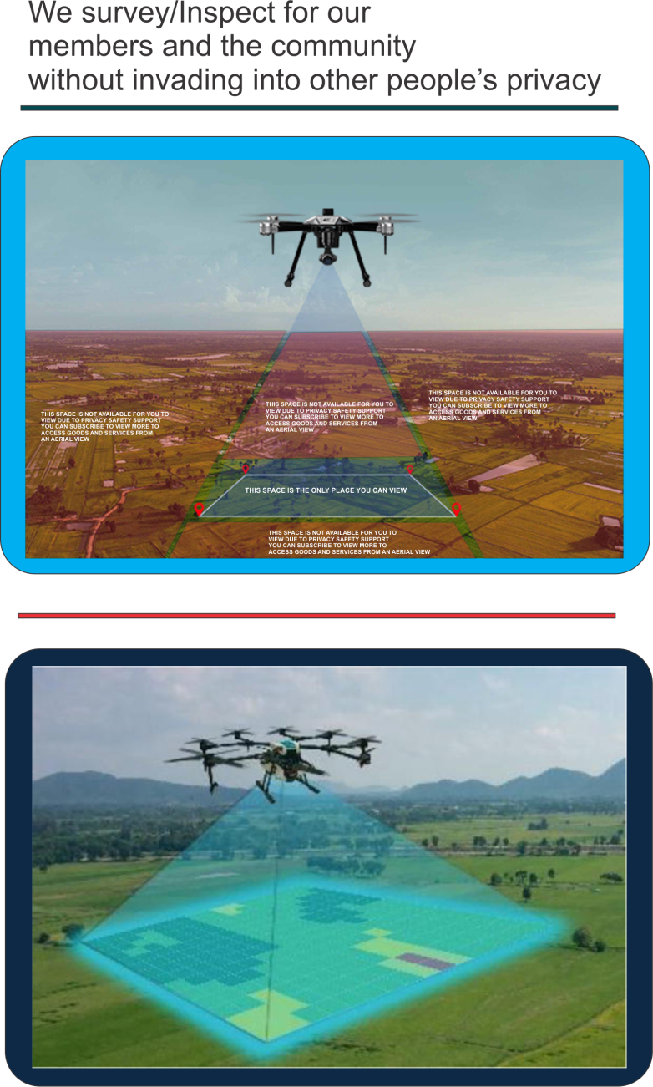



* Smart technology solutions, including **Smart Pillars** and **IDEIST (Intelligent Digital Electricity and Internet Services Transponder)**, ensure efficient management of utilities like water, electricity, and gas.

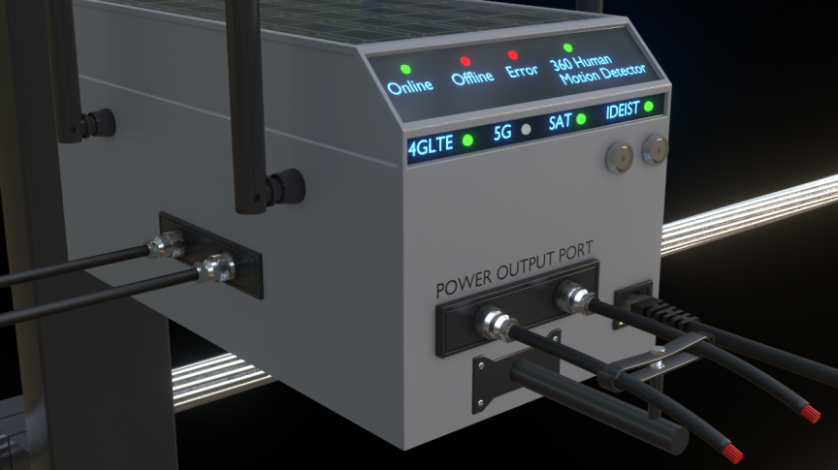

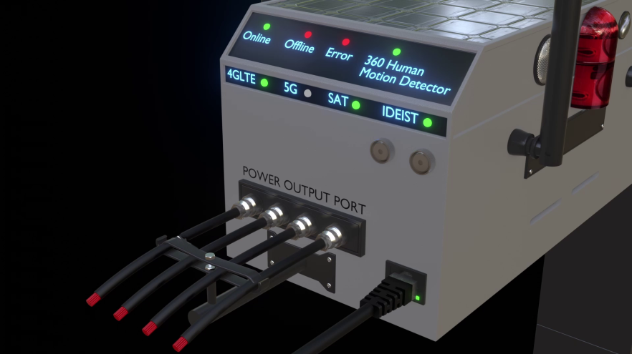

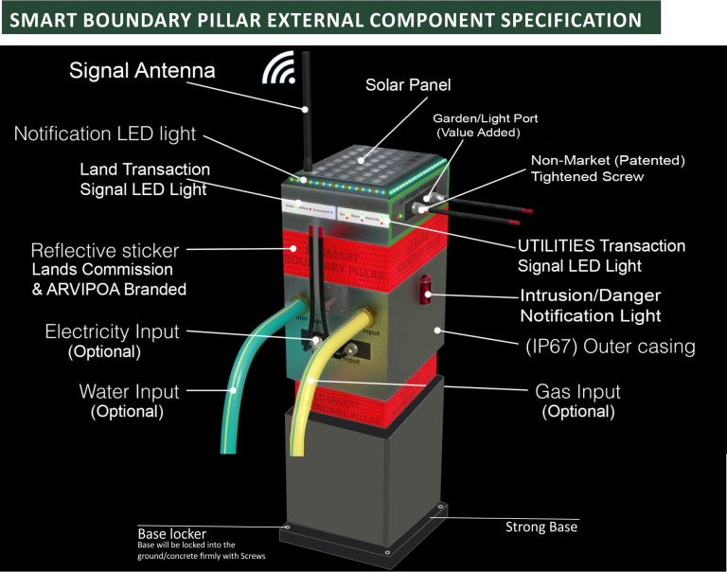

* Advanced surveillance systems, including **CCTV with face detection** and **real-time drone monitoring**, enhance property security.

3.2 **Marketing and Support**

* ARVIPOA provides professional photography, virtual tours using **MR VIEW smart spectacles**, and digital marketing for listed properties.
* Property owners can manage listings through live or virtual viewings facilitated by ARVIPOA agents.

3.3 **Daily Rent Scheme**

* ARVIPOA enables **pay-as-you-go rental options**, breaking down monthly rents into daily payments to cater to tenants with limited financial means.
* 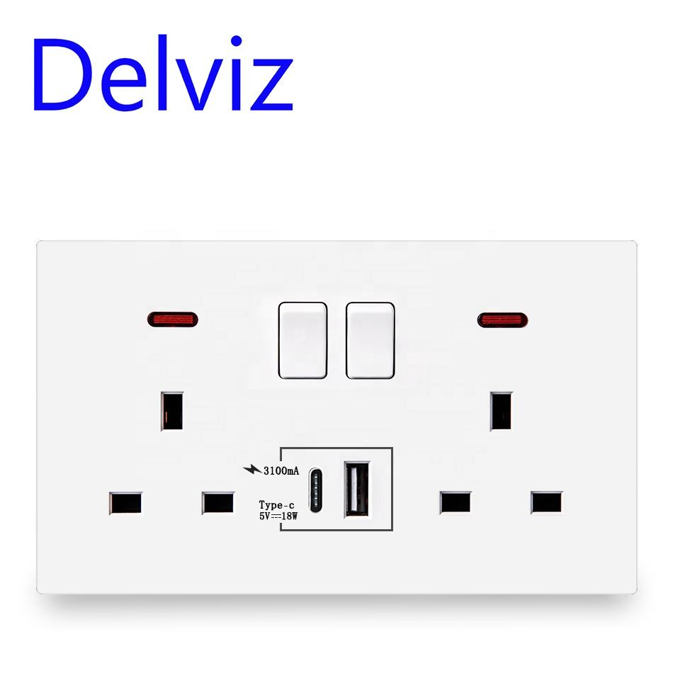Biometric locks, smart switches, and smoke detectors ensure fair usage and safety compliance.

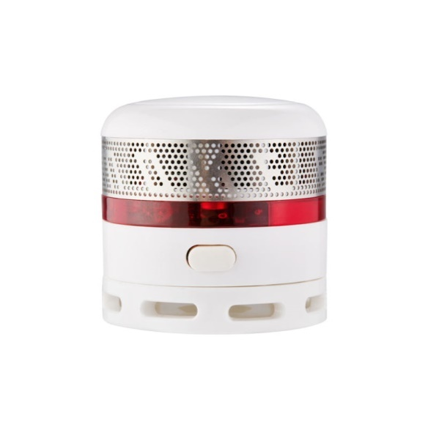

### 4. Property Registration and Smart Card Issuance

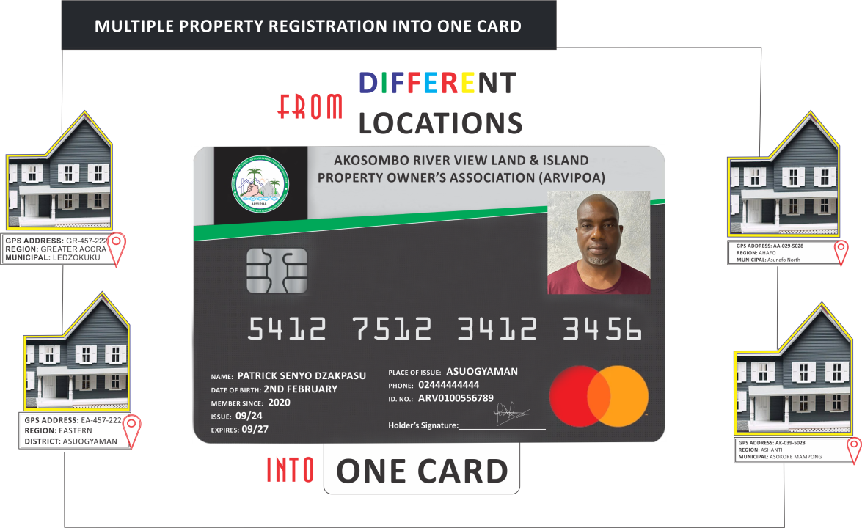**4.1 Property Smart Card**Every property owner registered on the ARVIPOA platform will receive a Property Smart Card after successfully creating their account.

* **Purpose:** This card securely stores all information about the owner’s registered properties, including physical and virtual addresses, land, houses, intellectual properties, and assets.
* **Accessibility:** Owners can use the Property Smart Card for quick access to property details, transfer of ownership, or verification processes.
* **Security:** The card is encrypted and linked directly to the owner’s ARVIPOA account for secure access and management.

**4.2 Property Categories**ARVIPOA supports the registration of a wide range of property types, including:

* **Land and Houses:** Residential, commercial, and undeveloped plots.



* **Virtual Properties:** Non-physical address, Private Mailbox, E-Sim

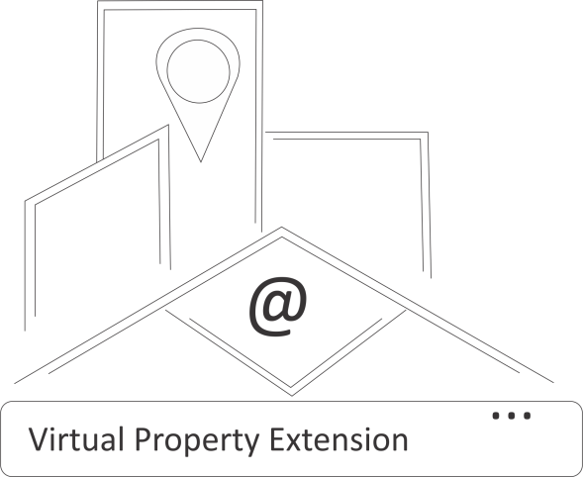

* **Intellectual Properties:** Patents, copyrights, trademarks, and other intangible assets.



* **Automobiles:** Cars, motorbikes, and other vehicles owned by the property owner.





* **Electronic and Digital Devices:** Phones, computers, and other valuable gadgets that the owner may wish to register for management or security purposes.

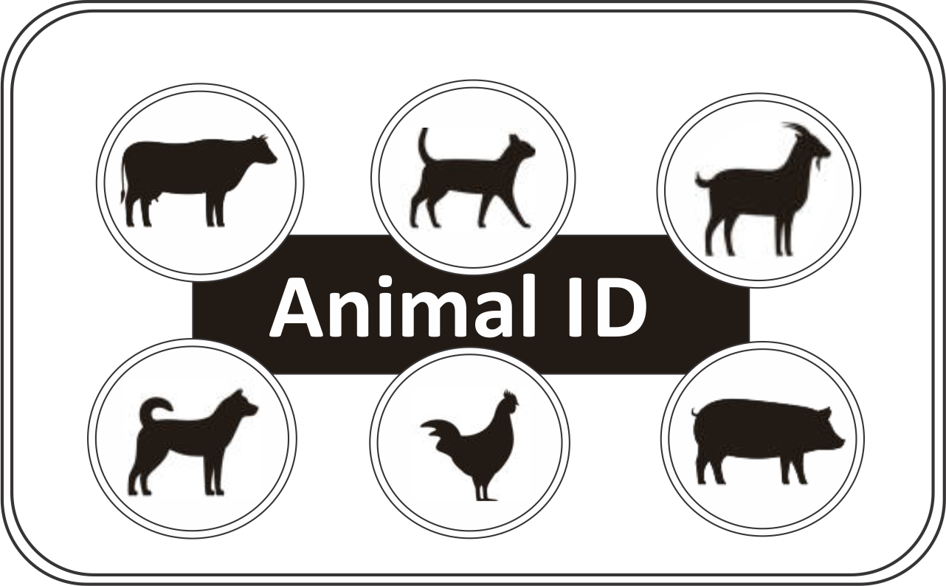

**4.3 Property Registration Process**

* Property owners must provide detailed information and supporting documentation for each property type.
* Intellectual properties require proof of ownership, such as official registration certificates or licenses.
* Automobiles and electronic devices require identification numbers (e.g., chassis numbers, serial numbers) and receipts of purchase or ownership.

**4.4 Management through the Smart Card**

* The Property Smart Card serves as the central hub for managing and viewing property details.



* Owners can access the ARVIPOA platform to update, transfer, or verify their registered properties using their smart card credentials.
* Lost or damaged smart cards can be replaced by contacting [support@arvipoa.org](mailto:support@arvipoa.org).



**4.5 Multi-Asset Integration**The platform’s innovative design allows property owners to manage diverse assets under a single account, ensuring seamless property management across categories.

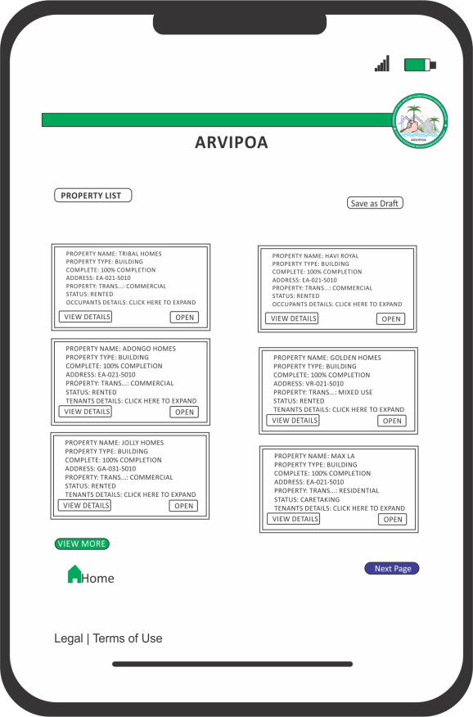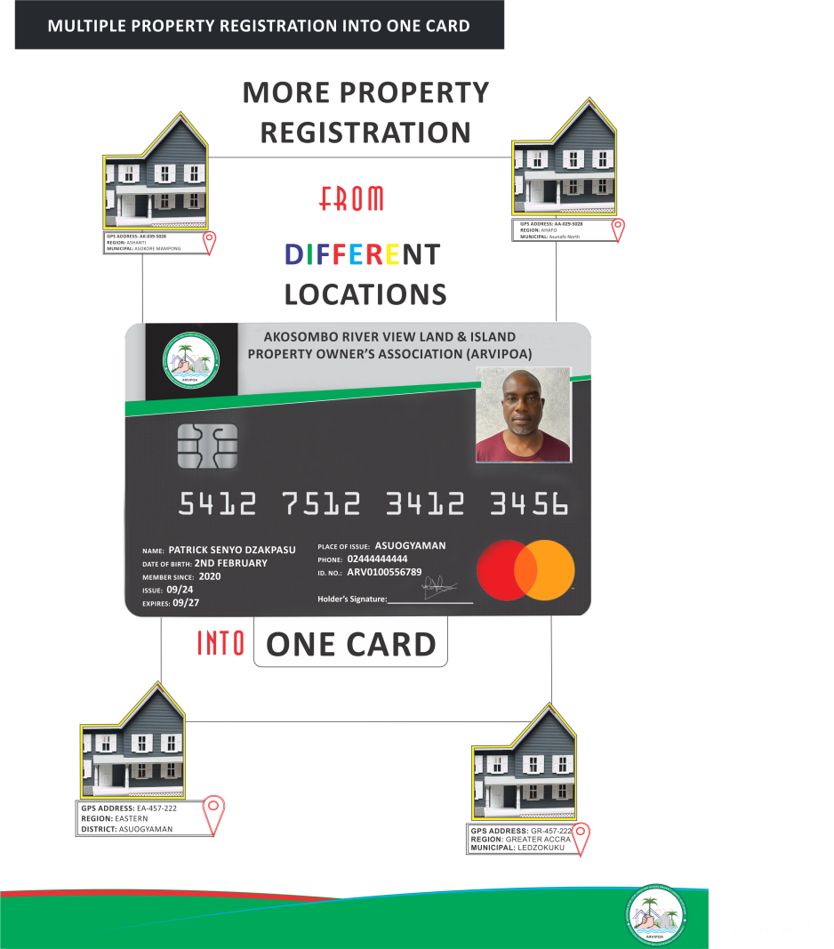

5. **4.5 Multi-Asset Integration**The platform’s innovative design allows property owners to manage diverse assets under a single account, ensuring seamless property management across categories.

### 5. River Security and Navigation Features

ARVIPOA offers a suite of innovative solutions to enhance the safety, security, and usability of rivers for property owners and other users. These features include underwater cameras, Smart Pillars, and the Smart River Defense Barricade (SRDB).

**5.1 Underwater Cameras**ARVIPOA installs underwater cameras beneath property owners' boats to monitor activities on the rivers.

* **Purpose**: These cameras deter illegal activities, ensure responsible usage of river resources, and enhance the safety of river navigation.
* **Data Privacy**: All footage is securely stored and accessed exclusively for compliance monitoring and safety purposes.
* **Maintenance**: ARVIPOA ensures regular upkeep of the cameras for consistent functionality.

**5.2 Smart Pillars for Navigation**Strategically installed Smart Pillars enhance river safety by marking hazardous areas, such as rocky zones notified.

* **Features:**
  + Equipped with LED lights and warning signals for clear visibility in all conditions.
  + Sensors detect nearby vessels to provide real-time alerts.
* **Regular Updates**: ARVIPOA monitors and upgrades these pillars as required to adapt to changing river conditions.

**5.3 Smart River Defense Barricade (SRDB)**The Smart River Defense Barricade (SRDB) is a cutting-edge solution to secure riverfront properties and provide added utility.

* **Security Features:**
  + Biometric Sensors: Grants access only to authorized individuals using facial recognition technology.
  + Thermal Imaging Cameras:
    - **Front Camera:** Monitors river activities.
    - **Rear Camera:** Secures the property owner's premises.
* **Utility Integration:**
  + Supplies clean, treated water directly from the river for property owners.
  + Powered by solar energy, ensuring continuous operation and eco-friendliness.
* **Professional Installation and Support**: ARVIPOA manages the installation and provides ongoing maintenance to guarantee efficiency and security.

### 6. Private Mailbox (PMB) Protection for Property Owners

ARVIPOA offers enhanced security for property owners’ **Private Mailboxes (PMBs)** to prevent unauthorized access and misuse.

**Security Features:**

* PMBs are equipped with advanced locking mechanisms and monitored through ARVIPOA’s surveillance systems.
* Owners receive real-time alerts in the event of an unauthorized access attempt.

**Added Benefits:**

* Property owners can integrate their PMB with ARVIPOA’s digital address system for efficient communication and document management.

### 7. Virtual Leasing for Foreign Business Establishments

Property owners can lease their physical spaces virtually to foreign entrepreneurs looking to establish businesses in Ghana.

**Comprehensive Business Package:**

* **Legal Documentation**: Includes a registered business name, incorporation certificate, and a Certificate to Commence Business, issued by the Registrar General Department, Accra.
* **Address Verification**: Provides a verified digital and traditional address, along with a Private Mailbox (PMB) and fax number.
* **Business Tools**: Includes a local phone number and other necessary resources to enable smooth business operations.

**Leasing Terms and Conditions:**

* Property owners must ensure that all leased spaces meet ARVIPOA’s guidelines for virtual leasing.
* Foreign businesses are required to adhere to Ghanaian laws and regulations as part of their leasing agreements.

### 8. Real-Time Auctioning of Properties

ARVIPOA facilitates transparent and engaging property auctions by equipping auctioneers with MR VIEW Glasses to provide a live, immersive experience for bidders.

**Auction Process:**

1. **Live Streaming:**
   * Auctions are broadcasted live on ARVIPOA’s dedicated auction website.
   * Viewers can watch the event in real-time and place their bids online.
2. **Bid Notifications:**
   * Bidders receive live updates about competing offers during the auction.

**Post-Auction Procedures:**

* The highest bidder will receive a Certificate of Purchase upon completing the payment process.
* Full payment must be made within 3 days of the auction’s conclusion. Failure to pay within the stipulated time will nullify the bid, and the property will be relisted for auction.

**Transparency and Security:**

* The auction process, including the use of MR VIEW Glasses, ensures fairness and transparency by providing real-time insights into the bidding process.
* All transactions and documentation are securely managed and verified by ARVIPOA.

### 9. Obligations of Property Owners

9.1 **Compliance with Laws**Property owners must ensure compliance with all local and international laws regarding property transactions, including submitting authentic documentation.

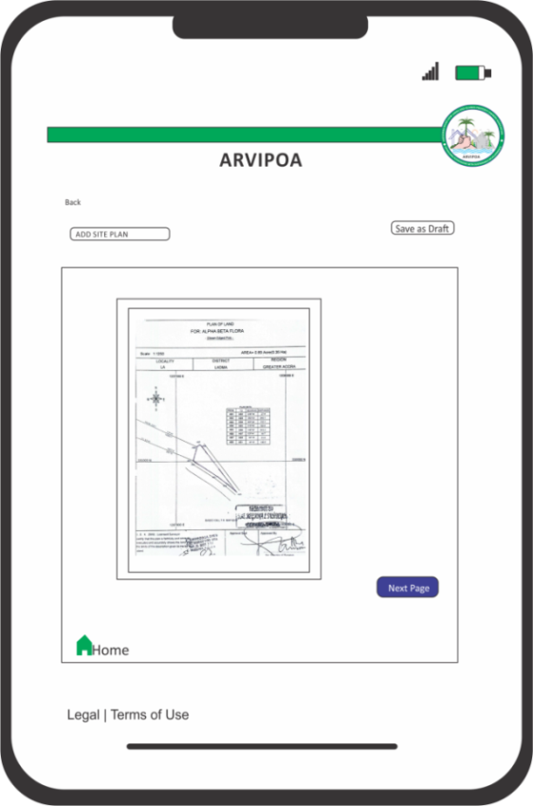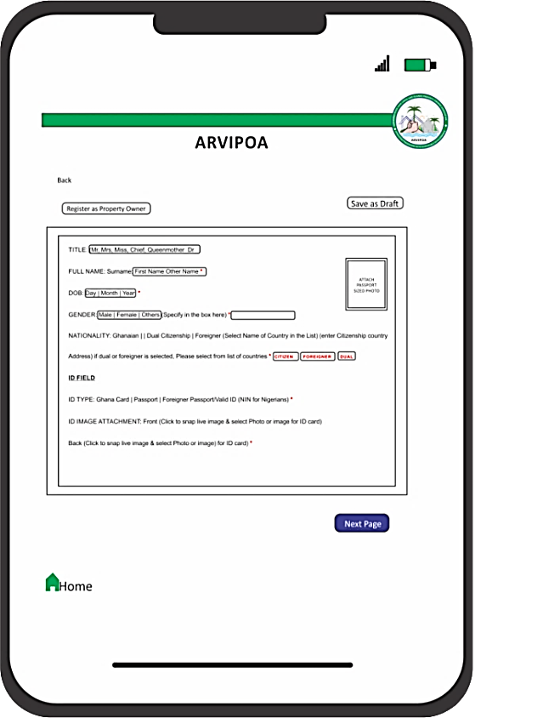

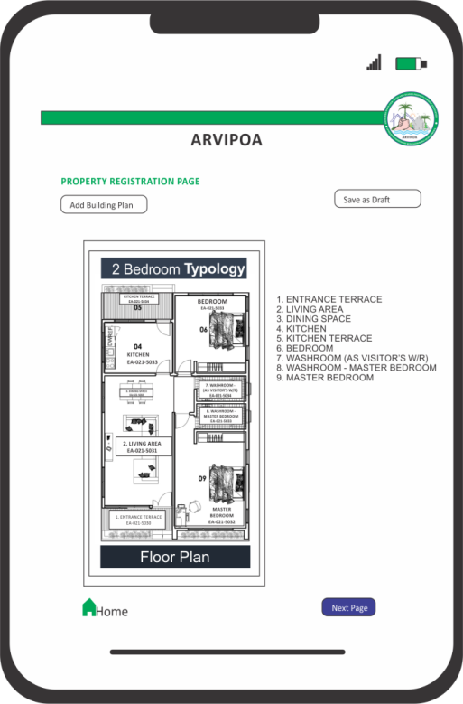

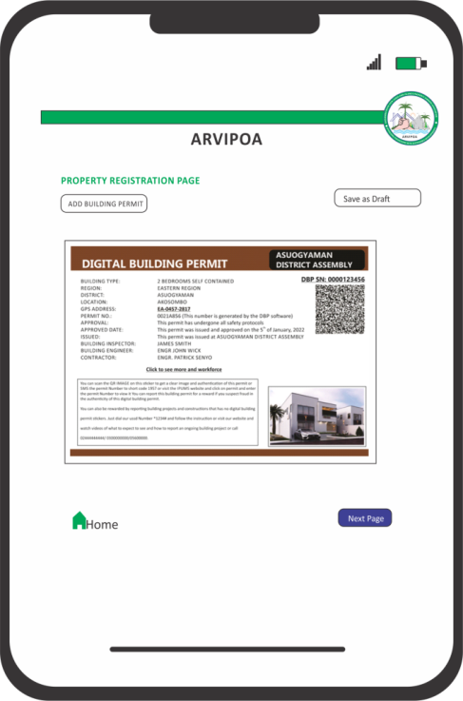

9.2 **Accurate Representation**

* Owners are responsible for providing truthful and complete information about their property.
* ARVIPOA disclaims liability for disputes arising from inaccurate or misleading listings.

9.3 **Tenant and Buyer Interactions**

* Communication with tenants or buyers must occur within the ARVIPOA platform for security and record-keeping purposes.
* External agreements or interactions are conducted at the property owner’s risk.

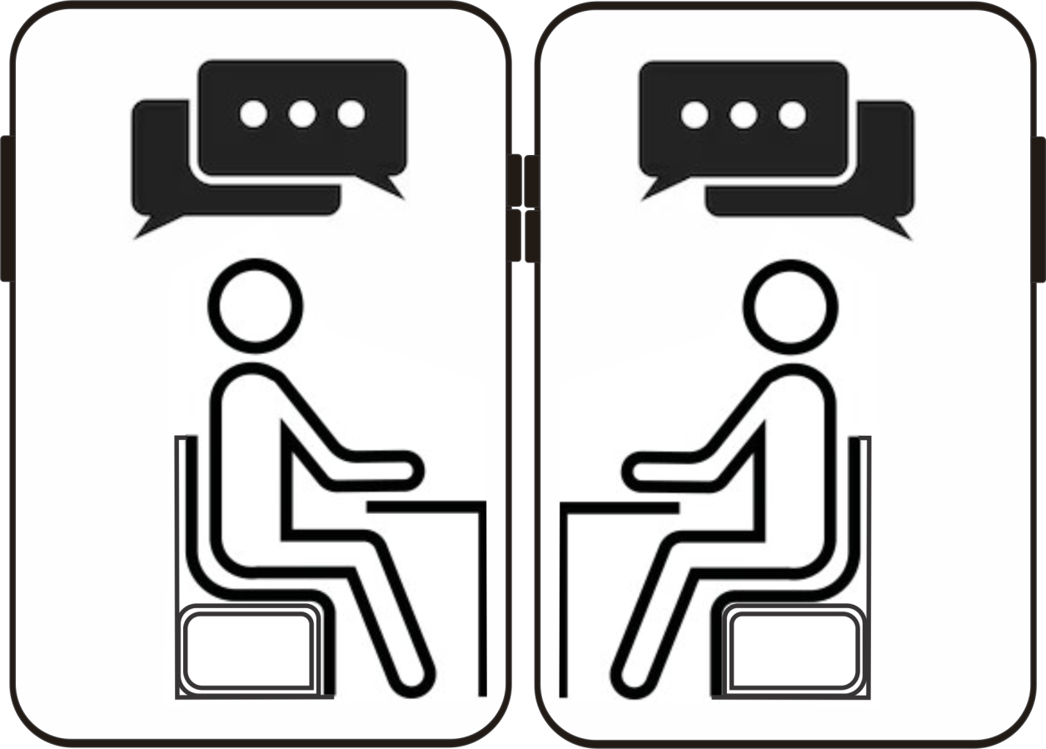

9.4 **Dispute Resolution**

* ARVIPOA offers an online **Arbitration Center**, enabling property owners and tenants to resolve disputes through video conferencing with legal and professional mediators.

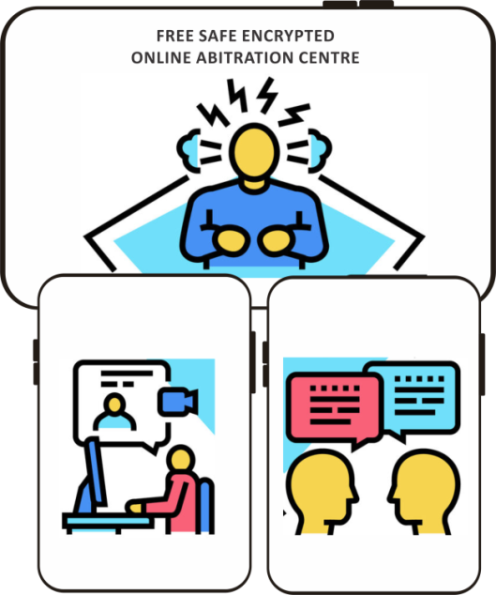

* Installed technologies, such as **CCTV and facial recognition**, provide evidence for dispute resolution and ensure fairness.

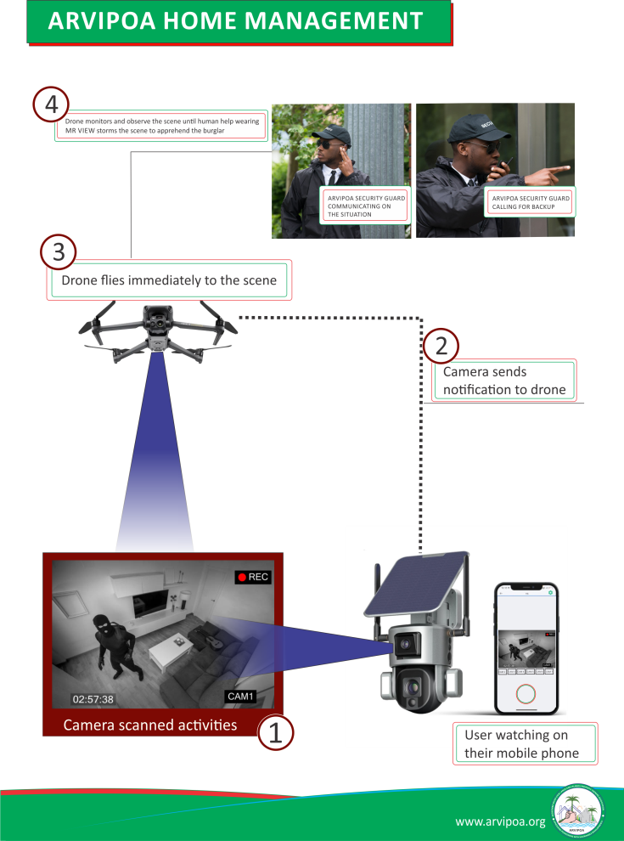

### 10. Prohibited Activities

Property owners are strictly prohibited from engaging in the following activities:

* Listing properties without proper ownership documentation or rights.
* Uploading false, exaggerated, or deceptive property information.
* Using the platform for illegal activities, such as money laundering or fraudulent schemes.
* Engaging in actions that harm ARVIPOA’s reputation, such as posting defamatory content or violating intellectual property rights.
* Allowing unauthorized agencies to manage properties listed on ARVIPOA.

### 11. Penalties for Non-Compliance

* Property owners who fail to honor agreements with tenants may face listing suspensions or removal.
* Any cancellations must comply with ARVIPOA’s policies to avoid disruptions in service.

### 12. Limitation of Liability

12.1 **Platform Availability**ARVIPOA strives to ensure uninterrupted access but does not guarantee continuous availability. Scheduled maintenance and unforeseen issues may result in temporary downtime.

12.2 **Transaction Outcomes**ARVIPOA facilitates transactions but is not liable for disputes, financial losses, or damages arising from such transactions. Property owners bear responsibility for all agreements.

### 13. Termination of Services

ARVIPOA reserves the right to suspend or terminate accounts for violations of these Terms. Terminated users will lose access to their property listings and associated services.

### 14. Refund Policy

* Fees for premium services are non-refundable after the rendering of services.
* Refunds may be issued solely at ARVIPOA’s discretion for technical issues preventing service access.

### 15. Governing Law

These Terms are governed by the laws of Ghana. Any disputes arising under these Terms will be resolved in any competent courts of jurisdiction located in any part of the country where the dispute happen at.

### 16. Contact Us

For questions or concerns about these Terms, please contact us at:  
**Akosombo River View Land and Island Property Owners Association LBG  
Address:** GES Madina Office, Presec, Accra Central,

P.O. Box CT3797, GM-006-0328, Greater Accra Region Ghana

Akosombo Office: H/NO. M30/1 AKOSOMBO

Official Whatsapp Number: +233548411284  
**Email:** [support@arvipoa.org](mailto:support@arvipoa.org)